**Departmment of Electronics & Telecommunication Engineering**

**University of Moratuwa**

|  |  |  |
| --- | --- | --- |
| Course: B.Sc. (Eng.), Semester 04 |  | |
| Subject: Electronics ΙII | Subject code: EN2110 | |
| **Simulation Assignment: Power Amplifiers** | | |
|  | | |
| Names: | | Admission Numbers: |
| Group: | | Date of Submission: |

**Objectives**: To study the behavior of standard types of power amplifiers using simulations.

**Software:** LTSpice

**Note:** You may modify the word document accordingly to insert the figures of simulation outputs.

***Use the following SPICE directives for the transistor models, BC639 and BC640. These parameters are extracted from: http://ltwiki.org/index.php?title=Standard.bjt.***

**BC639**

.MODEL BC639 NPN IS=6.119E-14 NF=0.9948 ISE=5.844f NE=1.469 BF=130.4 IKF=0.8 VAF=54.27 NR=0.9905 ISC=1.342E-13 NC=1.183 BR=14.53 IKR=0.2049 VAR=30 RB=0.5 IRB=1E-06 RBM=0.5 RE=0.1114 RC=0.082 XTB=0 EG=1.11 XTI=3 CJE=1.234E-10 VJE=0.6917 MJE=0.338 TF=6.543E-10 XTF=223.8 VTF=1.892 ITF=10 CJC=3.49E-11 VJC=0.5 MJC=0.388 XCJC=0.15 TR=10n FC=0.9232

**BC640**

.MODEL BC640 PNP IS=6.1530E-14 NF=0.9911 ISE=1.382E-16 NE=1.089 BF=150.8 IKF=1.225 VAF=105.4 NR=0.9965 ISC=6.480f NC=1.022 BR=8.074 IKR=0.3627 VAR=18.20 RB=2 IRB=1E-06 RBM=2 RE=5.562E-02 RC=0.1449 XTB=0 EG=1.11 XTI=3 CJE=1.157E-10 VJE=0.7300 MJE=0.3751 TF=8.666E-10 XTF=1.231 VTF=3.008 ITF=0.4581 CJC=5.264E-11 VJC=0.6591 MJC=0.4533 XCJC=0.4401 TR=2.75E-07 FC=0.9427

***PROCEDURE***:

**Simulation 1**: Class ‘**A**’ Amplifier

1. Connect the circuit as shown in figure 1 and paste your circuit diagram.



Figure1

1. Using the operating point simulations, obtain the DC bias voltages

VB = ……………………..

VE = ……………………..

VC = ……………………..

1. Paste a screen capture of operating point simulation output window.
2. Using the “signal” block, adjust the input signal at 10 kHz to the maximum output possible without clipping or distortion. Use probe options to measure and note down the maximum input & output values.

VI (max) = ……………………

VO (max) = ……………………

1. Paste the simulation output waveforms in both Y-T and X-Y modes.
2. Calculate the efficiency of the amplifier at this input level.
3. Reduce the input signal to the half of the signal level of step(c). Measure and note down the voltage values.
4. Calculate the efficiency of the amplifier at this input signal level.

**Simulation 2**: Class ‘**B**’ Amplifier

Class ‘B’ push-pull amplifier with two symmetric power supplies. (complementary symmetry)

1. Connect the push-pull (complementary symmetry) class ‘B’ power amplifier shown in figure 2. Paste your circuit diagram.

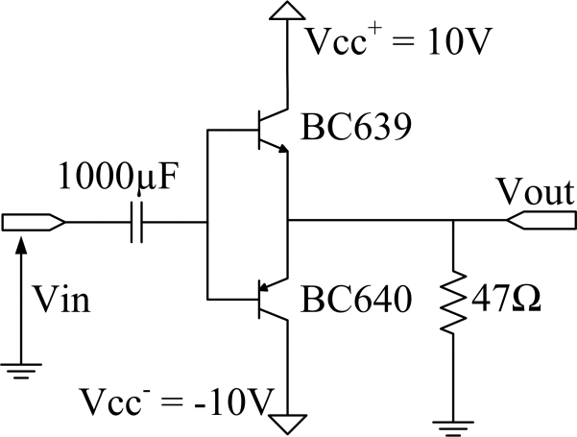

Figure 2

1. Increase the input voltage to the clipping limit & measure the maximum input and output values

VI (max) = ……………………

VO (max) = …………………..

1. Calculate the efficiency of the amplifier
2. Observe the cross over distortion at the output, insert Y-T and X-Y mode output plots.
3. Comment on your observations in (d).

**Simulation 3**: Class ‘**AB**’ Amplifier

1. Connect the offset complementary amplifier circuit as shown in figure 3. Paste your circuit diagram.

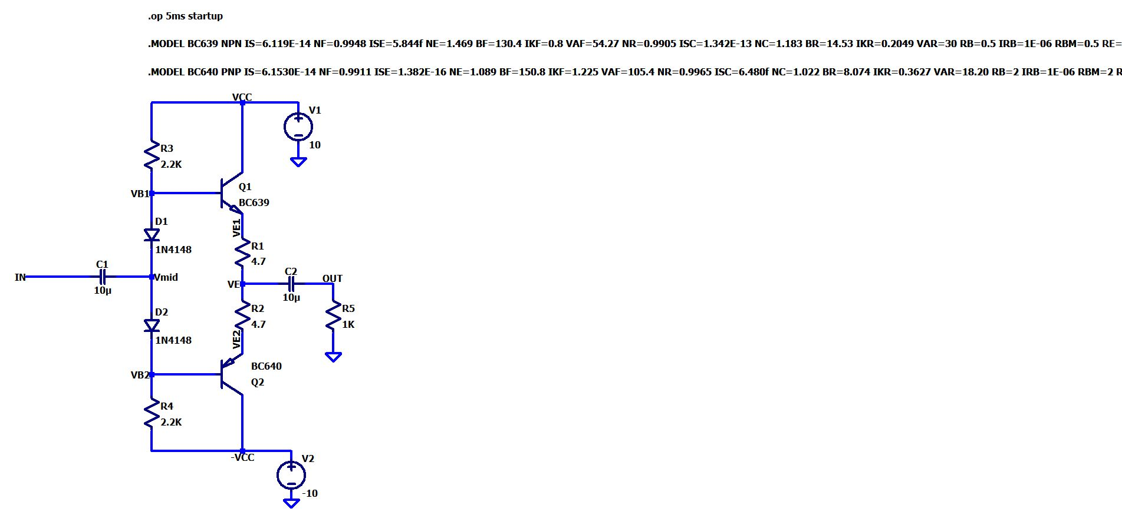

Figure 3

1. Using the signal block, adjust the 10 kHz input signal to the maximum output possible without clipping. Adjust *R1* and *R2* to remove the cross over distortion occurring at the output. Measure and note down the maximum voltages.

VI (max) = 9.457V VO (max) = 9.1009244V

1. Calculate the efficiency of the amplifier at this input signal level.
$$η=\frac{AC power decipated at the load}{Power delivered by the DC source}$$

$$η=\frac{P_{L,AC}}{P_{IN}}$$

$$P_{L,AC}=\frac{V_{O}^{2}}{2R_{L}}$$

$$P_{L,AC}=\frac{{9.1009244}^{2}}{2×1000}$$

$$P_{L,AC}=0.0414134W=41.4134mW$$

$$P_{IN}=\frac{2V_{CC}V_{O}}{πR_{L}}$$

$$P_{IN}=\frac{2×10×9.1009244}{π×1000}$$

$$P_{IN}=57.9382mW$$

$$η=\frac{41.4134mW}{57.9382mW}=0.714785=71.4785\%$$

2. Reduce the output to about 60% of the maximum output voltage. Measure and note down the following voltages.

VI = 5.5505V VO= 5.4605192V

1. Calculate the efficiency of the amplifier at this input signal level.
$$P_{L,AC}=\frac{{5.4605192}^{2}}{2×1000}=14.9086mW$$

$$P_{IN}=\frac{2×10×5.4605192}{π×1000}=34.7627mW$$

$$η=\frac{14.9086mW}{34.7627mW}=0.428867=42.8867\%$$

2. Remove the input signal. Using operating point analysis, measure and note down the DC voltages V*B1*, V*B2* and V*E*

VB1 = 651.181mV VB2 = -652.569mV

VE1 = 16.1633mV

VE2 = -17.9814mV

VE = -0.000909041V